# DEVELOPMENT OF

# FRONTEND RESTAURANT WEBSITE

Mr Keyeveh Hansen

Creative Infiny Group

**UNIVERSITY OF BUEA**

­

P.O Box 63

P.O Box 6

University of Buea

Dr. Djouela Ines

***Supervisor***

CAMEROUN

Buea, Sud Quest Region

**REPUBLIQUE DU CAMEROUN**

P.O Box 63

**REPUBLIC OF CAMEROON**

**Option:** Software Engineering

Matriculation Number: FE21A141

***Professional Supervisor***

ASONGLEFAC ZINGWA JOSEPH LIONEL

**By :**

**Academic Year 2024/2025**

*Internship Report Submitted to the Department of Computer Engineering, Faculty of Engineering and Technology, University of Buea, in Partial Fulfilment of the Requirements for the Award of the Bachelor of Engineering (B.Eng.) Degree in Computer Engineering*

**ACADEMIA VERSION 2**

**DEPARTMENT OF COMPUTER ENGINEERING**

**FACULTY OF ENGINEERING AND TECHNOLOGY**

PAIX - TRAVAIL - PATRIE

CAMEROON

Buea, South West Region

P.O Box 63

PEACE – WORK - FATHERLAND



**DEDICATION**

I dedicate this report to my mother, her support and encouragement have been a constant source of motivation throughout my internship journey and my life.

**ACKNOWLEDGEMENTS**

The internship opportunity I had with Creative Infiny Group was a great chance for learning professional development. Therefore, I consider myself as very lucky individual as I was provided with to be a part of it. I am also grateful for having the chance to meet so many wonderful interns and professionals who led me through this internship period. I will also like to appreciate the managing director of Creative Infiny Group who in spite of being extraordinarily busy with his duties, took time out to hear, guide and keep me on the correct path and help me reshape my ideas for a better internship experience. My sincere gratitude to my academic supervisor, Dr. Djouela Ines for her patience in walking me through my report and correcting the errors I made often too frequently

**TABLE OF CONTENT**

Chapter 1: Introduction 1

1.1 Definition of Internship 1

1.2 Goals and Objectives of the Internship 1

1.3 Posting/Application for Internship 2

1.3.1. Finding the Internship 2

1.3.2. Application Process 2

1.3.3. Acceptance and Duration 2

1.4 Company Presentation 2

1.4.1 About The Company 2

1.4.2 Objective of the Company 3

1.4.4 Organizational Structure 3

1.4.5 Activities/Services Provided by the Company 4

Chapter 2: Internship Activities 5

2.1 First Day at Internship 5

2.2 Technical Supervisor 5

2.2.1. Supervisor’s Name and Position 5

2.2.2. Guidance and Mentorship Throughout the Internship 6

2.3 Departments Assigned and Function 6

2.4 Tasks Assigned 7

2.4.1. Minor Tasks 7

2.4.2. Main Project 7

1. Background 7

2. Problem Statement 7

3. Objectives 7

4. Requirement Gathering Techniques for the Restaurant Website 7

5. Functional Requirements 8

5.1. User Features 8

5.2 Admin Features 8

6. Non-Function Requirements 8

7. Technologies Used 9

8. System Design 10

8.1. Development Diagrams 10

8.1.1. Use case Diagram 10

8.1.1.1. Actors 11

8.1.1.2. Use Cases and Descriptions 11

8.1.1.3. Diagram Explanation 12

8.1.2. Class Diagram 13

7.1.2.1 Classes ,Attributes , Methods and Relationships 14

8.2. UI/UX Design 17

1. Introduction 17

2. Color Scheme 17

3. Typography 17

9. Website Implementation 18

9.1. Navigation Bar 18

9.2. Page Descriptions 18

1. Home Page 18

2. Menu Page 19

3. Delivery Page 19

4. About Page 19

5. Contact Page 19

9.3. Design Principles 20

9.4. Architecture and Methodology 20

9.4.1. Architecture 20

9.4.2. Methodology 21

Chapter 3: Extra-Curricular Activities 27

3.1 Activities Organized by the Company 27

3.3. Lessons and Benefits 27

Chapter 4: Difficulties and Challenges Encountered 28

Chapter 5: Conclusion and Recommendations 29

5.1. Conclusion 29

5.2 Recommendations 29

5.2.1 For the Company: 29

5.2.2 For Future Interns: 29

5.2.3 For Academic Institutions: 30

References 31

Appendices 32

**Table of Figures**

Figure 1: Creative Infiny Ltd Organigram 3

Figure 2:Use Case Diagra 10

Figure 3: Class Diagra 13

Figure 4:Home Page of Restaurant Website 22

Figure 5:Menu Page of Restaurant Website 23

Figure 6: Delivery Page of Restaurant Website 24

Figure 7: About Page of Restaurant Website 25

Figure 8: Contact Page of Restaurant Website 26

# Chapter 1: Introduction

## 1.1 Definition of Internship

This internship report shares my experiences and challenges during my time as an intern. I faced several difficulties, such as limited practical experience, managing my time, and adapting to a new workplace culture. Learning to accept and use constructive feedback was also an important part of my growth. By seeking help from colleagues, prioritizing my tasks, and being open to learning, I was able to overcome these challenges. This internship not only improved my skills and confidence but also gave me a better understanding of the professional world, preparing me for future career opportunities. The lessons I learned will be valuable as I continue my journey in my field.

An internship is a period of work experience offered by an organization for a limited period.it is a professional learning experience that offers meaningful, practical work related to a student's field of study or career interest .an internship gives a student the opportunity for career explorations and development and to learn new skills. It offers the employer the opportunity to bring new ideas and energy into the workspace, develop talent and potentially build a pipeline for future full time employees.

## 1.2 Goals and Objectives of the Internship

This internship was taken for the following Reasons

* Exposes student to working environment and expectations of their companies and organization practices
* It serves as an opportunity for the student to apply classroom knowledge and theories related to engineering and technology to real-life experience in the industry
  + - To gain new skills in the engineering field by working on real world projects.
    - To learn and be familiarized with top-notch technologies related with software design and implementation.
    - To improve on the knowledge of engineering concepts by applying them in a closely monitored environment.
    - As a preparation for the transition from academia to the job world.
    - Asarequirementforacquisitionofabachelor’sdegreeinComputerengineering.

## 1.3 Posting/Application for Internship

### 1.3.1. Finding the Internship

Internship opportunities can often be discovered through various channels, including online job portals, university career centers, and personal networks. In this case, the opportunity was shared by a student already enrolled at the institute. Word-of-mouth recommendations from peers can be valuable in uncovering openings that may not be widely advertised.

### 1.3.2. Application Process

The process was straightforward and involved submitting the necessary information provided by the school. In addition, a formal application letter was required to express interest in the internship. Once these steps were completed, the application was processed without any additional requirements. This highlights the importance of following institutional guidelines and ensuring all necessary documents are properly submitted.

### 1.3.3. Acceptance and Duration

The internship application process started of in October 2024 as applications were dropped in several companies. The acceptance at Creative lasted from November 2024 till February 2025 for the internship program.

## 1.4 Company Presentation

### 1.4.1 About The Company

Creative Infiny.Ltd is one of the leading conglomerate companies in Buea. It is located at Last Floor, Unics PLC Molyko, Buea in the South West region of Cameroon. This company started in2013. One year later, in 2014, it was registered as a legal business entity in Cameroon. With ever increasing demand for employee and intends satisfaction in the workplace, their good qualities are worth nothing and adopting as best practices. They are the critical difference between a thriving company on its way to success and one that is treading water to stay afloat.

Some services offered by Creative-Infiny include:

### 1.4.2 Objective of the Company

Creative-Infiny Group has a vision to enhance the reputation, efficiency and profitability of small and medium businesses across Cameroon through the provision of supportive, powerful , cost effective and modern marketing support services in a way which gains local recognition but with worldwide presence. Creative-Infiny also has as vision to lead in advancing the use of computer technology in the face of scarce resources. Its mission is to ease the burden and improve on the quality of life of ordinary people by using computer programming and technology to resolve challenges of their daily living, especially in resource-limited settings through advance planning, renovation and innovation.

### 1.4.4 Organizational Structure

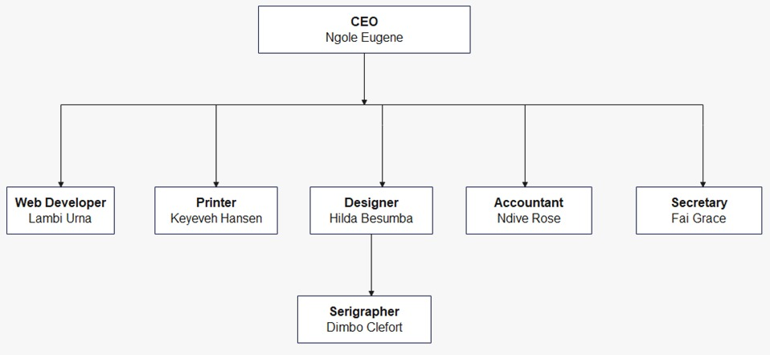

Figure 1: Creative Infiny Ltd Organigram

### 1.4.5 Activities/Services Provided by the Company

1. **Web development**

* Responsive web design
* Professional web development
* Advanced programming

1. **Digital Marketing**

* Digital marketing
* Affiliate marketing
* Social media marketing (SMM)

1. **Mobile Apps Development**

* Responsive App design
* Android and Ios Platforms
* Advanced UI And UX Programming

1. **Graphic Design**

* Basic to advanced graphic design
* Digital image editing
* Modern graphic concept

1. **Civil Engineering**

# Chapter 2: Internship Activities

## 2.1 First Day at Internship

On the first day at the software company, the internship program included a structured orientation that set a positive tone for the experience.

1. **Orientation Session**

The day began with an orientation session, providing an overview of the company's mission, values, and culture. This session was essential for understanding the organization and introduced interns to key team members, helping to create a sense of belonging within the company.

1. **Setup**

Following the orientation, interns received the necessary tools and resources to get started. This included setting up laptops and creating accounts for essential software and company systems. IT support was on hand to ensure that all software was installed and configured correctly, enabling a smooth start to the internship.

1. **Training**

Training sessions were held to familiarize interns with the technologies and tools used by the company. This training covered important topics such as coding standards, version control systems, and project management tools, providing interns with the knowledge needed to contribute effectively to ongoing projects.

1. **Regular Check-ins**

Throughout the day, regular check-ins with mentors were conducted to provide guidance and answer any questions. These conversations clarified responsibilities and offered valuable feedback on task management, ensuring that interns felt supported as they began their journey within the organization.

Overall, the first day was an informative and engaging experience, laying a solid foundation for the internship ahead.

## 2.2 Technical Supervisor

### 2.2.1. Supervisor’s Name and Position

Mr. Keyeveh Hansen is staff in Creative Infiny Group with position IT Support. He maintains, manages and fixes software and hardware related problems in the company. He always checked in on the interns and provided intern roles.

### 2.2.2. Guidance and Mentorship Throughout the Internship

**a) Ensuring Clear Expectations**

The supervisor establishes clear expectations by outlining the intern's roles, responsibilities, and objectives for the internship. This clarity helps interns understand what is expected of them, including specific tasks and performance standards.

**b) Providing Regular Feedback**

The supervisor ensures that regular feedback is given to the intern, offering constructive insights on performance. By highlighting strengths and addressing areas for improvement, the supervisor helps the intern understand their progress and refine their skills.

**c) Offering Support and Resources**

The supervisor provides essential support and resources, sharing training materials and granting access to necessary tools. This guidance empowers the intern to tackle challenges and complete their assignments effectively.

**d) Encouraging Questions and Learning**

The supervisor fosters an open environment by encouraging the intern to ask questions and seek clarification. This approach promotes a culture of curiosity and learning, allowing the intern to feel valued and engaged throughout their internship.

## 2.3 Departments Assigned and Function

**The intern was assignment as a frontend developer building user interface according to company design**

## ****2.4 Tasks Assigned****

### 2.4.1. Minor Tasks

### 2.4.2. Main Project

#### 1. Background

In the modern food service industry, having a user-friendly online platform is essential for restaurants to enhance customer experience, streamline ordering, and increase engagement. This system aims to create a frontend platform for a restaurant where customers can browse the menu, place orders online, and visit the restaurant for dine-in services.

#### 2. Problem Statement

Most restaurants lack a centralized digital platform where customers can conveniently view the menu, place orders, and contact the restaurant. The absence of an optimized frontend system leads to inefficiencies, affecting customer engagement and revenue generation.

#### 3. Objectives

* Design an interactive and responsive frontend for the restaurant.
* Implement an online ordering system with seamless cart functionality.
* Provide an intuitive UI/UX that enhances user experience.
* Ensure secure transactions through integration with WooCommerce.
* Allow users to browse the menu by category and add items to the cart.
* Implement a contact section for customer inquiries.

#### 4. Requirement Gathering Techniques for the Restaurant Website

In developing the restaurant website, we focused on understanding user and stakeholder needs through three key techniques: observation, brainstorming, and interviews.

* **Observation**

We observed potential users interacting with existing restaurant websites and apps. This hands-on approach revealed their navigation habits, preferences, and common challenges, helping us design a user-friendly experience that meets their needs.

* **Brainstorming**

Our team held brainstorming sessions to encourage creative idea-sharing among stakeholders. This collaborative environment allowed us to explore various features and design elements, ensuring we prioritized the most valuable functionalities for users.

* **Interviews**

We conducted interviews with restaurant owners, managers, and potential customers to gather in-depth insights about their expectations and experiences. These conversations highlighted desired features and concerns, guiding our design and development process.

By utilizing observation, brainstorming, and interviews, we gained a comprehensive understanding of user and stakeholder needs, allowing us to create a restaurant website that is functional, engaging, and tailored to our audience.

#### 5. Functional Requirements

##### 5.1. User Features

* Menu Browsing: Users can view food categories (e.g., Breakfast, Lunch, Beverages).
* Add to Cart: Users can add food items and adjust quantities.
* Online Ordering: Integrated with WooCommerce for order management.
* Payment Options: Support for Credit Card, PayPal, and Bank Deposit.
* Contact Form: Users can send messages to the restaurant.
* Restaurant Visit Information: Users can view restaurant details and location.

##### 5.2 Admin Features

* Menu Management: Update, add, or remove menu items.
* Order Management: Receive and track customer orders.
* Customer Interaction: Respond to inquiries.

#### 6. Non-Function Requirements

* **Performance:** Fast loading times optimized for mobile and desktop.
* **Security:** Use HTTPS, input validation, and secure payment integration.
* **Scalability:** Able to handle increased traffic and menu updates.
* **Cross-Browser Compatibility:** Works across Chrome, Firefox, Safari, and Edge.
* **Accessibility:** Follows WCAG standards for accessibility

#### 7. Technologies Used

1. **ReactJS**

ReactJS is a powerful JavaScript library for building user interfaces, particularly single-page applications. It enables the creation of reusable UI components, which helps in developing a modular architecture for the restaurant website. React’s component-based structure enhances maintainability and scalability, making it easy to manage the app as it grows.

1. **JavaScript**

JavaScript is the core programming language used throughout the project. It facilitates dynamic content rendering, event handling, and API interactions. By leveraging JavaScript, the website can provide an interactive user experience, such as smooth navigation between pages and real-time updates for menu items.

1. **CSS**

CSS (Cascading Style Sheets) is used for styling the website, ensuring that it adheres to design principles such as hierarchy, consistency, and responsiveness. Media queries and modern CSS techniques (such as Flexbox and Grid) are utilized to ensure the website is fully mobile responsive, providing an optimal viewing experience across devices.

By combining these technologies, the restaurant website is built to be efficient, user-friendly, and visually appealing, successfully meeting the needs of its audience.

#### 8. System Design

##### 8.1. Development Diagrams

###### 8.1.1. Use case Diagram

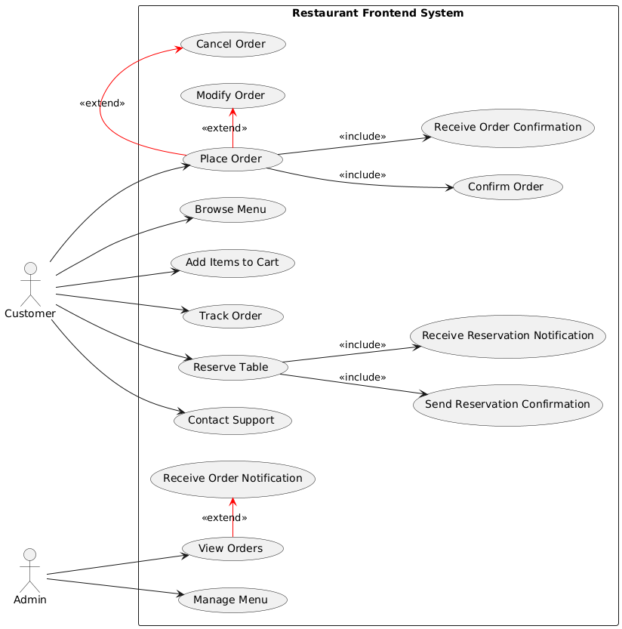

Figure 2:Use Case Diagra

The Use Case Diagram represents the interactions between the system and its users (actors). It outlines the primary functionalities provided by the restaurant frontend platform and their relationships.

8.1.1.1. Actors

* **Customer** - A user who interacts with the platform to browse the menu, place orders, make reservations, make payments, and contact support.
* **Admin -** A system administrator responsible for managing menu items, handling orders, processing reservations, and viewing reports.

8.1.1.2. Use Cases and Descriptions

1. **Browse Menu**

* **Description:** Allows customers to view available menu items categorized by meals and drinks.
* **Actor:** Customer

**2. Place Order**

* **Description:** Enables customers to select menu items and add them to their cart for checkout.
* **Actor:** Customer

**3. Make Reservation**

* **Description:** Allows customers to book a table at the restaurant for a preferred date and time.
* **Actor:** Customer

**4. Make Payment**

* **Description:** Facilitates secure payment processing for customer orders via various payment methods.
* **Actor:** Customer
* **Relationship:** Extends from Place Order

**5. Contact Support**

* **Description:** Enables customers to reach out to the restaurant for inquiries or assistance.
* **Actor:** Customer

**6. Manage Menu**

* **Description:** Allows admins to update menu items, including prices and availability.
* **Actor:** Admin
* **Relationship:** Extends from Browse Menu

**7. Manage Orders**

* **Description:** Enables admins to monitor and process customer orders.
* **Actor:** Admin
* **Relationship:** Extends from Place Order

**8. View Reports**

* **Description:** Provides admins with insights into orders, sales, and customer activity.
* **Actor:** Admin

**9. Handle Reservations**

* **Description:** Allows admins to manage and confirm table reservations.
* **Actor:** Admin
* **Relationship:** Extends from Make Reservation

8.1.1.3. Diagram Explanation

The system consists of two main actors: Customers and Admins. Customers interact with the system by browsing the menu, placing orders, making reservations, and contacting support. Admins, on the other hand, handle menu updates, order management, reservations, and system reporting. Certain actions such as "Make Payment" and "Manage Orders" are extensions of other processes.

This structured approach ensures smooth operation and a seamless user experience for both customers and administrators.

###### 8.1.2. Class Diagram

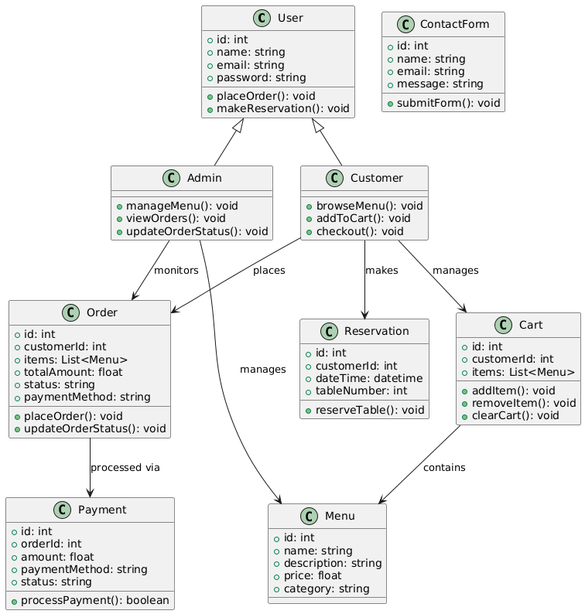

Figure 3: Class Diagra

7.1.2.1 Classes ,Attributes , Methods and Relationships

**1. User Class (Abstract)**

**Attributes:**

* id: int - Unique identifier for the user.
* name: string - Stores the user's full name.
* email: string - Stores the user’s email address.
* password: string - Stores the user’s password for authentication.

**Methods:**

* placeOrder(): void - Allows a user to place an order.
* makeReservation(): void - Allows a user to reserve a table.

**Relationships:**

Parent class for Customer and Admin.

**2. Customer Class (Inherits from User)**

**Methods:**

* browseMenu(): void - Allows the customer to view available menu items.
* addToCart(): void - Allows the customer to add food items to their cart.
* checkout(): void - Allows the customer to place an order from the cart.

**Relationships:**

* Inherits from User.
* Connected to Cart, Order, and Reservation classes.

**3. Admin Class (Inherits from User)**

**Methods:**

* manageMenu(): void - Allows the admin to add, update, or delete menu items.
* viewOrders(): void - Allows the admin to monitor all customer orders.
* updateOrderStatus(): void - Enables the admin to update order status.

**Relationships:**

* Inherits from User.
* Directly manages the Menu and Order classes.

**4. Menu Class**

**Attributes:**

* id: int - Unique identifier for each menu item.
* name: string - The name of the menu item.
* description: string - A short description of the dish.
* price: float - Price of the item.
* category: string - The food category (e.g., "Appetizers", "Main Course").

**Relationships:**

* Admins manage menu items.
* The cart contains menu items.

**5. Order Class**

**Attributes:**

* id: int - Unique order identifier.
* customerId: int - ID of the customer who placed the order.
* items: List<Menu> - List of menu items in the order.
* totalAmount: float - Total price of the order.
* status: string - Current status of the order.
* paymentMethod: string - Chosen payment method.

**Methods:**

* placeOrder(): void - Confirms order placement.
* updateOrderStatus(): void - Updates the order status.

**Relationships:**

* Customers place orders.
* Orders are processed via payments.

**6 Payment Class**

**Attributes:**

* id: int - Unique payment identifier.
* orderId: int - Associated order ID.
* amount: float - Payment amount.
* paymentMethod: string - Payment method used.
* status: string - Status of the payment.

**Methods:**

* processPayment(): boolean - Processes the payment and returns true if successful.

**7. Cart Class**

**Attributes:**

* id: int - Unique cart identifier.
* customerId: int - ID of the customer who owns the cart.
* items: List<Menu> - List of menu items added to the cart.

**Methods:**

* addItem(): void - Adds a menu item to the cart.
* removeItem(): void - Removes a menu item from the cart.
* clearCart(): void - Clears all items from the cart.

**Relationships:**

* Customers manage their carts.
* Carts contain menu items.

**8. Reservation Class**

**Attributes:**

* id: int - Unique reservation identifier.
* customerId: int - ID of the customer who made the reservation.
* dateTime: datetime - Date and time of the reservation.
* tableNumber: int - Assigned table number.

**Methods:**

* reserveTable(): void - Confirms the table booking.

**Relationships:**

Customers make reservations.

**9. ContactForm Class**

**Attributes:**

* id: int - Unique form identifier.
* name: string - Customer’s name.
* email: string - Customer’s email.
* message: string - The submitted message.

**Methods:**

* submitForm(): void - Sends the inquiry message to the restaurant.

##### 8.2. UI/UX Design

###### 1. Introduction

A restaurant frontend platform must provide an intuitive, visually appealing, and functional user experience. The UI design ensures brand consistency, ease of navigation, and high accessibility while maintaining a modern aesthetic.

###### 2. Color Scheme

The chosen colors define the brand identity and enhance usability while ensuring contrast for readability.

* **Primary Color: #C3512F (Burnt Sienna - Brand Identity)**

This warm and inviting color reflects the restaurant's passion and energy. It is used for primary buttons, headers, and key call-to-action (CTA) elements, drawing user attention to important actions.

* **Secondary Color: #FFD700 (Gold - Accents and Highlights)**

Gold represents luxury and high-quality service. It is used for accentuating important features, such as hover states, active menu items, and notifications, adding a premium touch to the interface.

* **Background Color: #F8F9FA (Soft White - Clean and Neutral)**

A light, neutral shade that creates a fresh and modern look while improving readability. It serves as the main background color, ensuring contrast with text and UI components.

###### 3. Typography

A structured typography system ensures a modern and readable experience while maintaining a professional feel.

**Headings: Poppins (Bold)**

* Used for main titles, section headers, and CTA elements.
* A modern and elegant typeface that enhances brand identity.
* Ensures strong visual hierarchy by differentiating sections.

**Body Text: Roboto (Regular)**

* Used for paragraphs, menu descriptions, form inputs, and notifications.
* A clean and highly readable font, optimized for both desktop and mobile screens.
* Maintains legibility even in smaller sizes.

This UI design ensures a modern, engaging, and accessible experience for restaurant customers. By combining a cohesive color scheme, structured typography, and well-defined UI components, the platform delivers a seamless and brand-consistent user experience.

#### 9. Website Implementation

The restaurant website is designed with a focus on user experience and design principles such as hierarchy, consistency, and Gestalt principles. The site is fully mobile responsive, ensuring a seamless experience across all devices.

##### 9.1. Navigation Bar

The navigation bar is a crucial element of the website, providing users with easy access to the main sections:

* Home
* Menu
* Delivery
* About
* Contact

The navbar is fixed at the top of the page, allowing for easy navigation regardless of the user's scroll position. It is styled consistently across all pages, using a cohesive color scheme and typography that reflects the restaurant's branding.

##### 9.2. Page Descriptions

###### 1. Home Page

**Purpose:** The home page serves as the welcoming entry point for visitors, offering an overview of the restaurant’s offerings and atmosphere.

**Features:**

* A hero image showcasing the restaurant or signature dishes.
* A brief introduction to the restaurant, highlighting its unique selling points.
* Links to popular sections of the site, such as featured menu items or special promotions.

###### 2. Menu Page

**Purpose**: This page presents the full menu, allowing customers to explore available dishes and drinks.

**Features:**

* Organized sections (e.g., appetizers, mains, desserts, beverages) that follow a clear hierarchy, making it easy for users to find what they’re looking for.
* Descriptions and prices for each item, with appealing images to entice customers.
* Filtering options for dietary preferences (e.g., vegetarian, gluten-free) to enhance user experience.

###### 3. Delivery Page

**Purpose:** This page provides information about the delivery services offered by the restaurant.

**Features:**

* Details on delivery areas, estimated delivery times, and any minimum order requirements.
* A call-to-action button for users to place an order online or view delivery options.
* Integration of a map or service area visual to enhance clarity.

###### 4. About Page

**Purpose:** The about page shares the story of the restaurant, its mission, and the team behind it.

**Features:**

* Engaging content that reflects the restaurant’s values and history.
* Profiles or photos of key team members to create a personal connection with customers.
* Testimonials or awards to build credibility and trust.

###### 5. Contact Page

**Purpose:** This page allows customers to get in touch with the restaurant for inquiries or feedback.

**Features:**

* Contact form for users to submit questions or requests directly.
* Display of contact information (phone number, email, address) for easy access.
* A map integration showing the restaurant's location for convenience.

##### 9.3. Design Principles

* **Hierarchy:** The website's layout follows a clear visual hierarchy, using different font sizes, weights, and colors to guide users' attention to the most important elements.
* **Consistency:** Design elements, such as colors, fonts, and button styles, are consistent throughout the website, creating a cohesive look and feel.
* **Gestalt Principles**: The website utilizes Gestalt principles like proximity (grouping related items together) and similarity (using consistent styles for buttons and links) to enhance usability and comprehension.

##### 9.4. Architecture and Methodology

In developing the restaurant website, a well-defined architecture and methodology were essential to ensure a structured and efficient approach. This report outlines the architectural framework and the methodology used throughout the project.

###### 9.4.1. Architecture

The architecture of the restaurant website follows a **Component-Based Architecture**, which is particularly suited for React applications. This approach allows for the creation of reusable components that can be independently developed, tested, and maintained. Key architectural features include:

* **Component Hierarchy:**

The website is organized into a hierarchy of components, such as the Navbar, Home, Menu, Delivery, About, and Contact components. Each page is represented as a separate component, allowing for easy navigation and management of different views.

* **State Management:**

A centralized state management solution, such as React Context or a state management library like Redux, is implemented to manage the application state. This ensures that components can share data efficiently and respond to user interactions seamlessly

* **Routing:**

The website utilizes React Router to handle navigation between different pages. This allows for a single-page application experience, where users can navigate without reloading the entire page, enhancing performance and user experience.

* **Responsive Design:**

The architecture incorporates responsive design principles, ensuring that the website adapts to various screen sizes and devices. CSS media queries and flexible layouts are utilized to achieve a mobile-friendly design.

###### 9.4.2. Methodology

The development of the restaurant website follows an Agile methodology, which emphasizes iterative progress, collaboration, and flexibility. The key aspects of this methodology include:

* **Iterative Development:**

The project is divided into small, manageable iterations, allowing the team to develop features incrementally. Each iteration includes planning, development, testing, and feedback, enabling continuous improvement and adaptation.

* **Collaboration and Communication:**

Regular communication among team members and stakeholders is prioritized through stand-up meetings and collaborative tools. This ensures everyone is aligned on project goals, progress, and any challenges that may arise.

* **User-Centered Design:**

User feedback is gathered throughout the development process to ensure the website meets user needs and preferences. Techniques such as user testing and feedback sessions are integrated into each iteration to refine features and enhance usability.

This frontend restaurant website is designed with user experience and design principles at its core. By providing a well-structured navigation system, engaging content, and a responsive design, it effectively meets the needs of its audience while showcasing the restaurant's offerings.

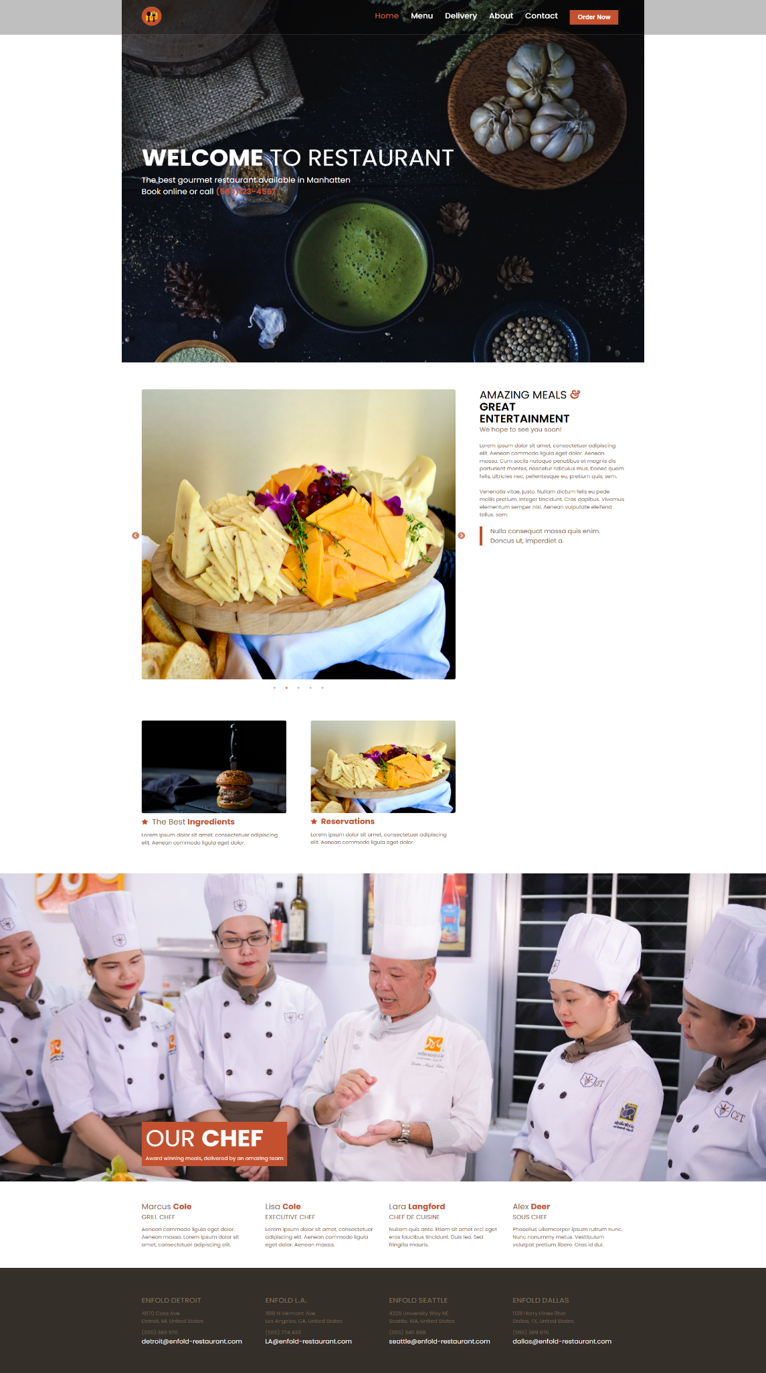

Figure 4:Home Page of Restaurant Website

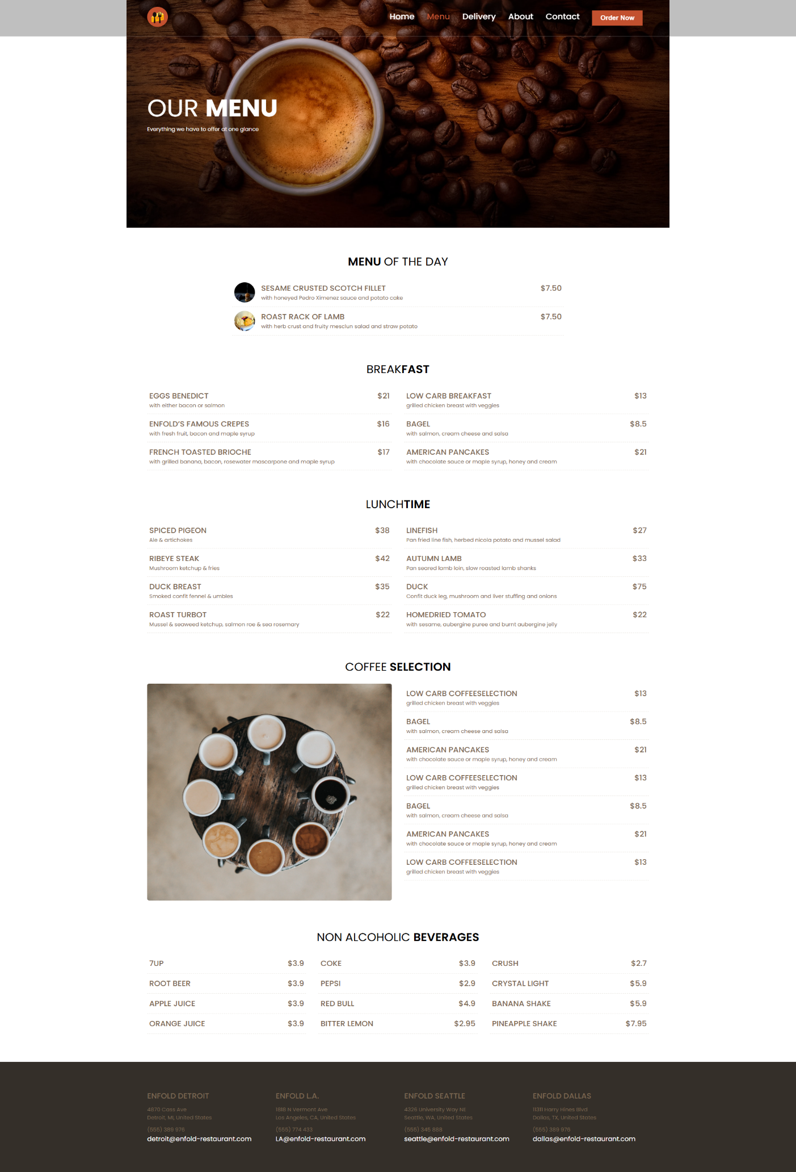

Figure 5:Menu Page of Restaurant Website

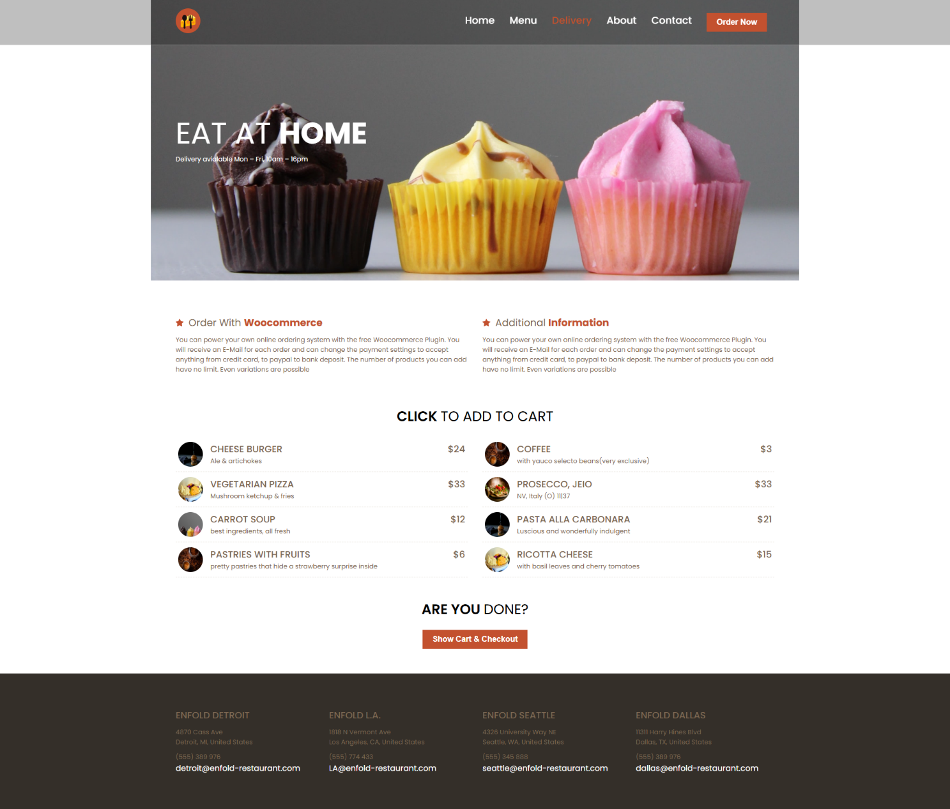

Figure 6: Delivery Page of Restaurant Website

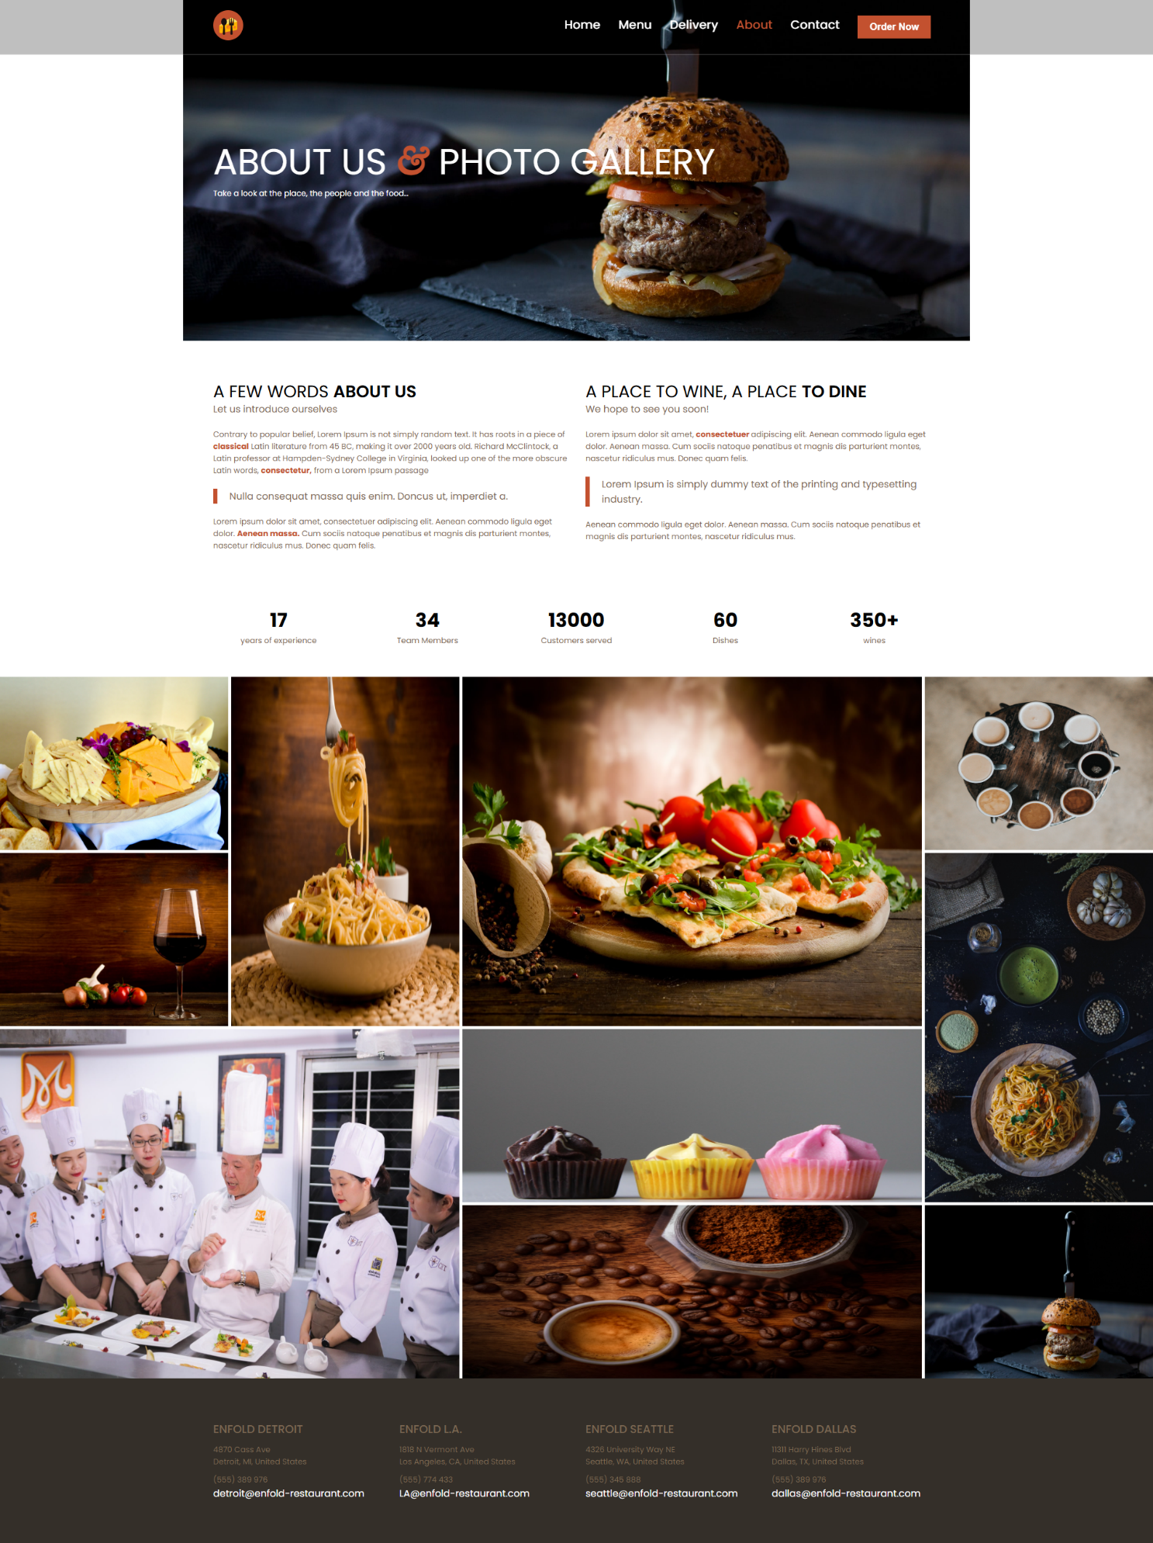

Figure 7: About Page of Restaurant Website

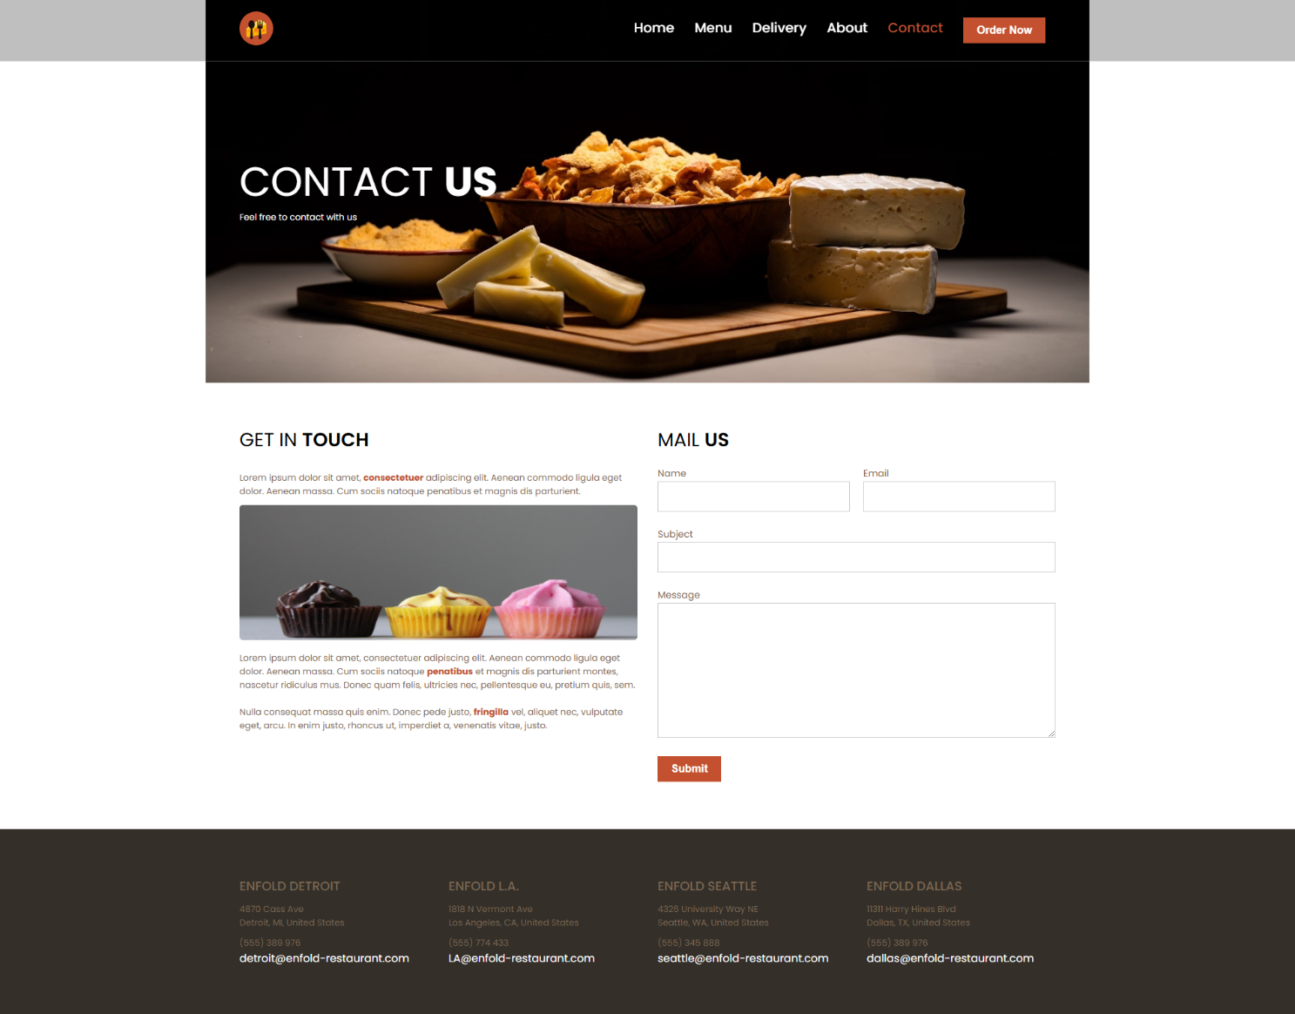

Figure 8: Contact Page of Restaurant Website

2.

# Chapter 3: Extra-Curricular Activities

## 3.1 Activities Organized by the Company

**1. Events participation**

Some of The Company’s most valuable partners and clients invited the company to participate in multiple opening events, ceremonies, birthday parties and marriages most especially when they participated in one way or the other to make this celebration a success; this was an opportunity for me to experience a whole lot of events and exposure.

**2.Volunteering:**

The company gives opportunity to interns who will volunteer in publicizing the company’s products. This involved sharing of fliers and post of creative-infiny services on Facebook, whatsapp, instagram and other social media platforms. These activities help community by sensitizing small businesses and other young fresh men who believe in technology.

**3 End of month meet ups**

At the end of every month, interns from all working department who have free time are called upon to join the company’s staffs in their outing, this help the interns to share their company experience and also help them to bond socially with themselves and other company staff’s

## 3.3. Lessons and Benefits

Participating in various activities at Zinger Systems Limited provided me with valuable lessons and professional growth:

**1. Skill Development:**

* Teamwork: Collaborating with colleagues during activities like Monday Share and Friday Share strengthened my ability to work in diverse teams.
* Communication: Sharing ideas and discussing setbacks in team meetings improved my ability to express thoughts clearly and constructively.

**2. Networking and Connections:**

* Engaging in team activities, such as company outings and the New Man Task, helped me build relationships with colleagues, creating a supportive professional network.

# Chapter 4: Difficulties and Challenges Encountered

During the internship, several challenges were faced that helped professional growth. This section highlights the difficulties encountered and how they were addressed.

**1. Lack of Experience**

Interns often face challenges due to limited practical experience, making it tough to perform tasks effectively. Many assignments required specialized skills that were still in development, leading to delays and uncertainty.

**Solution:** Seeking guidance from experienced colleagues and conducting independent research were crucial. Regular practice and being open to feedback helped improve skills over time.

**2. Time Management**

Juggling multiple tasks and deadlines in a fast-paced environment was challenging. Without proper planning, it was easy to feel overwhelmed by competing responsibilities.

**Solution:** Prioritizing tasks by urgency and using productivity tools helped with organization. Breaking projects into smaller steps made it easier to manage workloads and track progress.

**3. Adapting to Workplace Culture**

Adjusting to a new work culture and communication styles took time. Misunderstandings about workplace norms sometimes hindered collaboration.

**Solution:** Observing colleagues and asking for clarification when needed provided valuable insights. Actively participating in discussions helped build confidence and improve communication.

**4. Handling Feedback**

Receiving constructive criticism was initially difficult, as it often pointed out areas needing improvement. This sometimes made it hard to ask for help.

**Solution:** Viewing feedback as a growth opportunity helped shift the mindset. Embracing suggestions and implementing them led to noticeable improvements in work quality.

# Chapter 5: Conclusion and Recommendations

## 5.1. Conclusion

As an undergraduate of the department of software engineering, Faculty of engineering and technology (FET), University of Buea, I would like to say that this internship training program is an excellent opportunity for me to get to the ground level and experience the things that I would have never gained through going straight into job. I am grateful to the university and Creative Infiny Group international for giving me this wonderful opportunity.

The main objective of the industrial training is to provide an opportunity to undergraduates to identify, observe and practice how engineering is applicable in the real industry. It is not only to get experience and technical practices but also to observe management practices and to interact with on field workers, it is easy to work with your private computer and an internet connection but not with people. The only chance that and undergraduate have to get the experience is through internship training period, I feel I got the maximum out of that experience. Also, I learnt the way of work in an organization, the importance of being punctual, the importance of maximum commitment and the importance of team spirit. In my opinion I have gained lots of knowledge and experience as a software developer needed to be successful in a great engineering challenge, as in my opinion engineering is after all a challenge , not a job.

## 5.2 Recommendations

### 5.2.1 For the Company:

* Creative Infiny group should give allowances to interns most especially transport allowances to cater for transport cost, most students stay far from the internship places hence increasing my expenses. Therefore I recommend creative infiny group international to put that in to action in order to motivate interns and boost their productivity levels in performing their tasks during the field attachment.

### 5.2.2 For Future Interns:

* Be proactive in seeking guidance and learning new technologies.
* Manage time effectively by breaking down tasks into smaller, manageable steps.
* Maintain open communication with supervisors and team members for better collaboration.

### 5.2.3 For Academic Institutions:

* Collaborate with companies to align internship objectives with academic curricula.
* Prepare students for real-world tasks by introducing industry-relevant tools and frameworks in coursework.
* By addressing these recommendations, the internship experience can be more effective and rewarding for all parties involved.

# References

Beck, K., & Andres, C. (2005). Extreme programming explained: Embrace change (2nd ed.). Addison-Wesley.

Chacon, S., & Straub, B. (2014). Git from the inside out. Git Tower.

Fowler, M. (2004). Inversion of control containers and the dependency injection pattern. Retrieved from https://martinfowler.com/articles/injection.html

Martin, R. C. (2008). Clean code: A handbook of agile software craftsmanship. Prentice Hall.

Rosenberg, J., & Stevens, D. (2007). Agile software development with Scrum. Prentice Hall.

W3C. (2021). Responsive web design. Retrieved from <https://www.w3.org/TR/css3-mediaqueries/>

Wirth, N. (1971). Program development by stepwise refinement. Communications of the ACM, 14(4), 221-227. https://doi.org/10.1145/365230.365257

# Appendices